IB Geography – Hazards & Disasters
Case Study Summary Sheet for Hurricane Katrina, USA (MEDC)
Where did it happen?
Hurricane Katrina is the costliest natural disaster in the history of the United States. Among recorded Atlantic hurricanes, it was the sixth strongest overall but what made it deadly was where it hit and the physical and human geography of that region. After crossing southern Florida - where it left some 100,000 homes without power - it strengthened further before veering inland towards Louisiana, eventually making landfall at Grand Isle, approximately 90km south of New Orleans, at 10am local time on 29 August. At this point, Katrina's sustained wind speed was approximately 200 km/h. The storm passed directly through New Orleans, destroying many lighter buildings and causing extensive damage to others.
Hurricane force winds were recorded along a 200km stretch of coastline, with scenes of similar destruction and flooding in Louisiana, Mississippi and Alabama. Storm surges from the sea caused flooding several kilometers inland in some places.
New Orleans has always been vulnerable to flooding, it sits by Lake Pontchartrain and the Mississippi river for a start. The wetlands of the Mississippi delta that used to protect New Orleans have diminished in size because they have been drained and because they are starved of sediment because the Mississippi river is so heavily embanked against flooding it stops erosion upstream which prevents deposition downstream. New Orleans is also sinking! The drained soft sediments it is built upon have compacted under the weight of the buildings, and the draining of water that supported the structure of the soil has also had an impact.
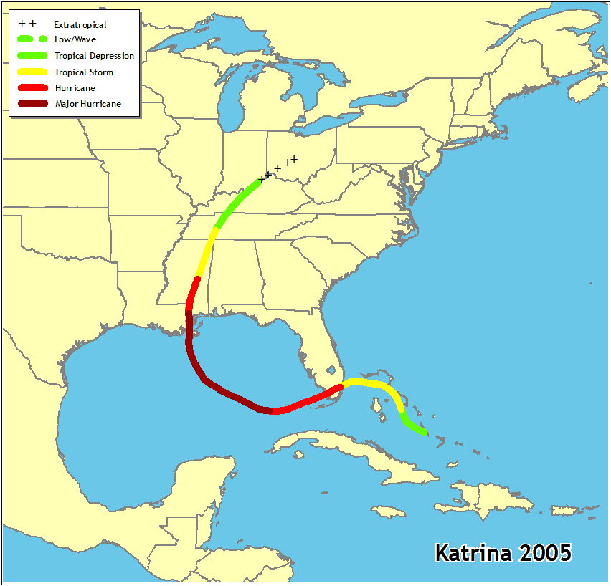

CIA Fact Box – USA Need To Know
Indicator | Values (2014 estimated)
GDP per capita PPP | $52800
People Living in Poverty (less than $2 per day) | 15% of the population
Access to Clean Water | 99.4% of the population
Life Expectancy | 79.56 years
Literacy Rate | 99%
People Per Doctor | 2.42 doctors per 1000 people

When did it happen?
Hurricane Katrina made landfall at Grand Isle, approximately 90km south of New Orleans, at 10am local time on 29 August 2005.
Why did it happen?
The traditional recipe for hurricane formation (sea temperatures over 27°c and rotating winds over the ocean's surface) applies here. Katrina originated over the Bahamas on August 23 from the interaction between a tropical wave and the remnants of Tropical Depression Ten. Early the following day, the new depression intensified into Tropical Storm Katrina. The cyclone headed generally westward toward Florida and strengthened into a hurricane only two hours before making landfall Hallandale Beach and Aventura on August 25. After very briefly weakening to a tropical storm, Katrina emerged into the Gulf of Mexico on August 26 and began to rapidly deepen. The storm strengthened to a Category 5 hurricane over the warm waters of the Gulf of Mexico, but weakened before making its second landfall as a Category 3 hurricane on August 29 in southeast Louisiana.
Who was affected by it happening?
Social Impacts | Economic Impacts
Katrina redistributed over one million people from the central Gulf coast elsewhere across the United States. For example, Houston, Texas, had an increase of 35,000 people  By late January 2006, about 200,000 people were once again living in New Orleans, less than half of the pre-storm population.  By July 1, 2006, when new population estimates were calculated by the U.S. Census Bureau, the state of Louisiana showed a population decline of 219,563, or 4.87%  Many people were traumatised  Racial tensions were exposed and intensified, as many of the victims were black African Americans | The Bush Administration sought $105 billion for repairs and reconstruction in the region, this didn’t include potential interruption of the oil supply, destruction of the Gulf Coast's highway infrastructure, and exports of commodities such as grain.  Katrina damaged or destroyed 30 oil platforms and caused the closure of nine refineries;  1.3 million acres (5,300 km2) of forest lands were destroyed costing about $5 billion  Before the hurricane, the region supported approximately one million non-farm jobs, with 600,000 of them in New Orleans.  It is estimated that the total economic impact in Louisiana and Mississippi may exceed $150 billion  Additionally, some insurance companies have stopped insuring homeowners in the area because of the high costs from Hurricanes Katrina and Rita, or have raised homeowners' insurance premiums to cover their risk
Environmental Impacts | Political Impacts
The storm surge caused substantial beach erosion, in some cases completely devastating coastal areas. In Dauphin Island, approximately 90 miles (150 km) to the east of the point where the hurricane made landfall, the sand that comprised the barrier island was transported across the island into the Mississippi Sound, pushing the island towards land  The lands that were lost were breeding grounds for marine mammals, brown pelicans, turtles, and fish  The damage from Katrina forced the closure of 16 National Wildlife Refuges.  The storm caused oil spills from 44 facilities throughout southeastern Louisiana, which resulted in over 7 million U.S. gallons (26 million L) of oil being leaked.  Finally, as part of the cleanup effort, the flood waters that covered New Orleans were pumped into Lake Pontchartrain, a process that took 43 days to complete. These residual waters contained a mix of raw sewage, bacteria, heavy metals, pesticides, toxic chemicals, and oil, which sparked fears in the scientific community of massive numbers of fish dying | The government was criticised for its response, with many critics claiming it was very slow to respond and that the management lacked coordination.  The use of emergency centres was also criticised, with the Louisiana Superdome (designed to handle 800, yet 30,000 arrived) and the New Orleans Civic Center (not designed as an evacuation center, yet 25,000 arrived) deemed by many as inadequate.  Race and class were also stipulated as issues, with Kanye West claiming that there was a racial reason for the slow response, given that most of the stranded people were African American.

What happened? *Leave this until we complete the next section on risk assessment and adjustments & responses to hazards
Management of the hurricane hazard in New Orleans
Before the event
The storm was predicted by the National Hurricane centre and they gave a very accurate plot of the Hurricanes track and expected landfall, not far from New Orleans. This allowed for a coordinated EVACUATION but many people were left behind and many refused to move. This warning also allowed some disaster recovery response to Katrina began before the storm, with Federal Emergency Management Agency (FEMA) preparations that ranged from logistical supply deployments to a mortuary team with refrigerated trucks.

During the event

After the event –
Of the 60,000 people stranded in New Orleans, the Coast Guard rescued more than 33,500. The United States also had a military on-scene response on Sunday, August 28. Approximately 58,000 National Guard personnel were activated to deal with the storm's aftermath, with troops coming from all 50 states.

Planning, preparation, prediction, hazard mapping, evacuation, warnings.

Help with recovery, aid - local, regional and international, role of NGOs.
Rescue (short) Rehabilitation (Medium) Reconstruction (Long)
Task: Some information is included below. Sort into the 3 R’s above and carry out additional research to fill in any blanks that you may have.

Most of the management and aid in response to hurricane Katrina came from within the USA (INTERNAL FEDERAL aid). Many volunteers gave assistance to local residents and residents emerging from New Orleans and surrounding parishes as soon as the storm made landfall (even though many were directed to not enter the area), and continued for more than six months after the storm.

The international community also responded quickly, with over seventy countries pledging monetary donations or other assistance. Kuwait made the largest single pledge, $500 million; whilst India sent tarps, blankets and hygiene kits. An Indian Air Force IL-76 aircraft delivered 25 tonnes of relief supplies for the Hurricane Katrina victims at the Little Rock Air Force Base, Arkansas on September 13, 2005. Charitable NGOs such as the American Red cross also waded in with assistance.

